**Project Design Phase-II**

**Technology Stack (Architecture & Stack)**

|  |  |
| --- | --- |
| Date | 19 november 2022 |
| Team ID | PNT2022TMID592924 |
| Project Name | MARINE MASTERPIECES: IMAGE CLASSIFICATION OF EXQUISITE SEA CREATURES |
| Maximum Marks | 4 Marks |

**Architecture diagram ->**

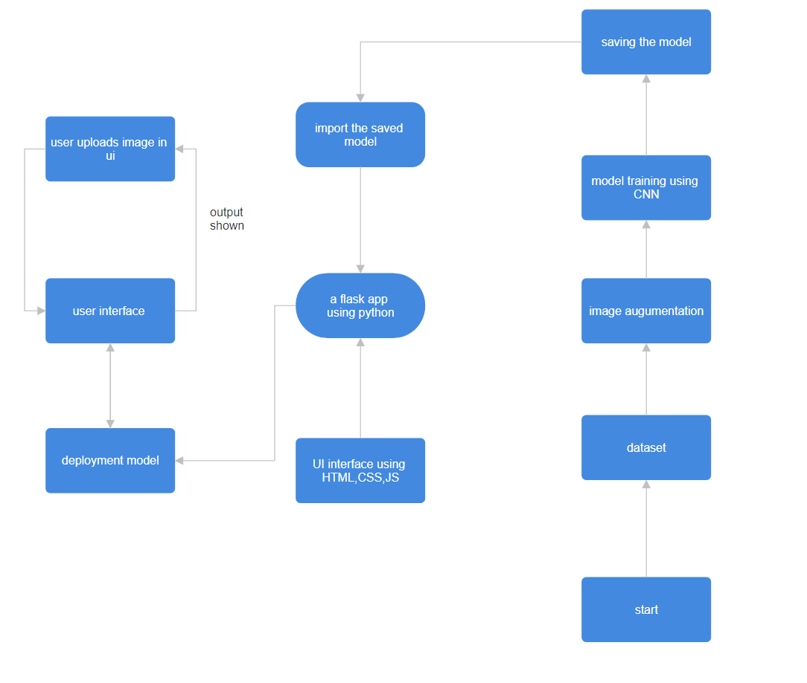

|  |  |  |  |
| --- | --- | --- | --- |
| **S.No** | **Component** | **Description** | **Technology** |
| 1. | User Interface | . Web app UI | HTML, CSS, JavaScript |
| 2. | Application Logic-1 | U click on lets start , get redirected to upload.html where u upload the image of the marine animal u want to identify | Python |
| 3. | Database | The data set has be obtained from kaggle . | File Manager. |
| 4. | File Storage/ Data | Dataset has been stored in the local system and accessed by the model through the path specified | Local System |
| 5. | Frame Work | Used to Create a web Application, Integrating Frontend and Back End | Python Flask, |
| 6. | Deep Learning Model | Image identification through multiple learning process | CNN |
| 7. | Infrastructure (Server / Cloud) | Application Deployment on Local System , all the files of the app along with the model are needed . | Local |

**Table-2: Application Characteristics:**

|  |  |  |  |
| --- | --- | --- | --- |
| **S.No** | **Characteristics** | **Description** | **Technology** |
| 1. | Open-Source Frameworks | List the open-source frameworks used | Python’s Flask |
| 3. | Scalable Architecture | Justify the scalability of architecture | Webapps and other niche softwares |
| 4. | Availability | Justify the availability of application (e.g. use of load balancers, distributed servers etc.) | Can be accessed by anyone who has the source files |

|  |  |  |  |
| --- | --- | --- | --- |
| 5. | Performance | Design consideration for the performance of the application (number of requests per sec, use of Cache, use of CDN’s) etc. | It can work individually well for anyone , one request at a time. |